Case 03: Testing the Virus Counter

Vasiliy Rodin

Purpose: The purpose of this test is to see if the function setupGame in the model correctly draws the infection cards from the infection deck which should be randomized during the shuffle stage.

Procedure:

* Start a new game
* Choose 2-4 players.
* Name these players.
* Show the board
* Check which cities have virus counters.
* Write down which cities have viruses and how many
* Do this again and compare the viruses from the last build.
* Game1: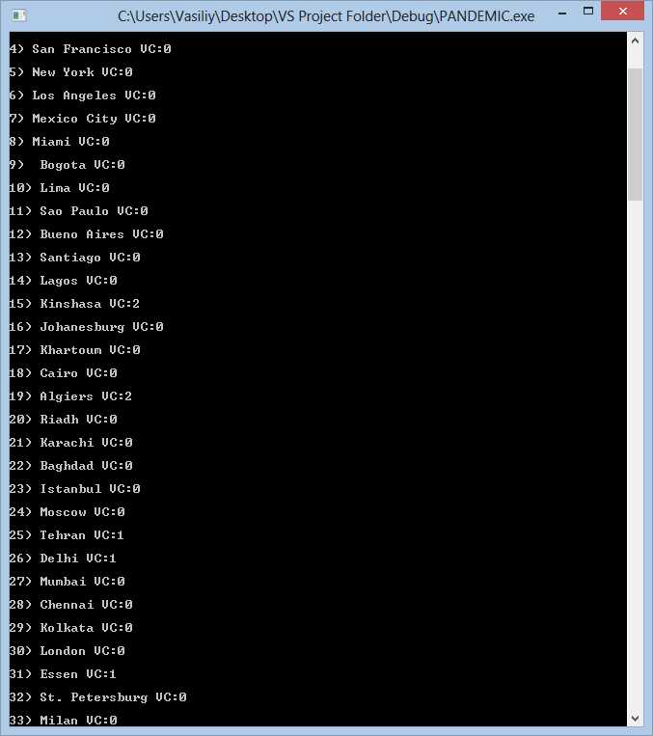

Game 2: 